PIRIMIPHOS-METHYL
Determination of Release Characteristics
of Pirimiphos-methyl formulation CS300

Collaborative Study

Small Scale Collaborative Study
for the
Determination of
Release Characteristics of
Pirimiphos-methyl formulation CS300, by
Capillary Gas Chromatography

Report to CIPAC
by
Syngenta Crop Protection AG
Dr. A. McIntyre / Susanne De Benedictis
Im Breitenloh 5
CH-4333 Münchwilen
Switzerland

June 2011

Content page

1. Participants 3
2. Active Ingredient, General Information 4
3. Samples 5
4. Method 5
4.1 Scope 5
4.2 Principle 5
4.3 Procedure 5
5. Remarks of the Participants 5
6. Evaluation and Discussion 6
6.1 Data Review 6
6.2 Statistical Evaluation 6
7. Conclusions 16

Participants

Cichy, Michael Dr. | Bayer CropScience AG  Industriepark Höchst  65926 Frankfurt a.Main  Germany
Dardemann, Jörg. Dr. | Stähler International GmbH&Co.KG  Stader Elbstrasse  21683 Stade  Germany
Distler, Jürgen Dr. | BASF SE  Postfach 120  67117 Limburgerhof  Germany
Hirsbrunner, Urs | Syngenta Crop Protection Münchwilen AG  Im Breitenloh 5  4333 Münchwilen  Switzerland

Participants are listed in alphabetical sequence, lab numbers in the result tables were assigned in sequence of result receipt.

Active Ingredient, General Information

Chemical name: O-2-diethylamino-6-methylpyrimidin-4-yl O, O-dimethyl phosphorothioate

ISO common name: Pirimiphos-methyl

CAS-Nr.: 29232-93-7

Structure:

Molecular mass: 305.3

Empirical formula: C₁₁H₂₀N₃O₃PS

Activity: Insecticide

Samples

Three test samples and 2 analytical standards were sent to the participants:

1. Pirimiphos-methyl CS300, sample 1
- Pirimiphos-methyl CS300, sample 2
- Pirimiphos-methyl CS300, sample 3
- Pirimiphos-methyl analytical standard, 99.2 % purity
- Dicyclohexyl phthalate internal standard

Results were received by the beginning of April 2011 from all participants.

Method

Scope
Determination of the Release Rate of pirimiphos-methyl in formulation CS300.

Principle
A known quantity of the capsule suspension is transferred to a glass bottle, diluted further with a small amount of water, before being subjected to a rolling movement with a specified amount of an n-hexane/ethanol mixture containing an internal standard. The bottle was rolled for 180 minutes and samples of the solvent layer taken after 15 minutes, 60 minutes and 180 minutes. The amount of pirimiphos-methyl in the solvent layer, at each of these time points, was determined by capillary gas chromatography.

Procedure
Each sample was analyzed using four independent determinations. The samples were analyzed on two different days, each by duplicate injections of two independent weighings. Test and reference solutions were prepared fresh on each day. In order to calculate the response factor the mean of the response factor (double injection) before and after the samples were used (bracketing). The sample content was calculated using the mean value of the duplicate injections.

Remarks of the Participants

The following deviations, from the method, were noted by several participants:

Laboratory 1 The horizontal roller could handle only 22 rpm. The GC column had a 30m length. The carrier gas was nitrogen. The flow rate of the carrier gas was 6 ml/min due to the different carrier gas and longer column. Temperature during extraction was 22.7°C

Laboratory 2 no comments

Laboratory 3 The only available roller had a bottle speed of 32 rpm; at day one the 60 min interval was taken at 75 min

Laboratory 4 no comments

Evaluation and Discussion

Data Review

The data obtained from each laboratory was reviewed to determine if there were any significant chromatography differences, from what was expected, which might affect the analytical results.
Visual examination of the chromatograms indicated no significant chromatographic differences from what was expected.
The concentration obtained on day one at 75 min (Lab 3) was used in conjunction with the 15 min value to interpolate the 60 min point. This enabled a direct comparison of all laboratories.
All method deviations, noted by the participants, were deemed not to affect the analysis results significantly.

Statistical Evaluation

Results reported by the laboratories and the statistical evaluation of these are listed in tables 1-5 and displayed in figures 1-12. The results for the release rate are expressed as a percentage of the total AI content. This value was provided by Syngenta to each laboratory prior to the study being commenced.

The statistical evaluation of the data was accomplished following the “Guidelines for CIPAC Collaborative Study Procedures for Assessment of Performance of Analytical Methods”, according to DIN ISO 5725. The data was examined for outliers and stragglers using Cochran’s test (within-lab variance), followed by Grubb’s test on the lab means (between lab variance). The tests were performed at an alpha level of 0.01 for outlier, and 0.05 for straggler detection.

The Cochran variance homogeneity test identified one straggler and two outliers –

Straggler:- sample 2, 60 min release time (Lab 1)
Outliers:- sample 2, 15 min release time (Lab 1)
sample 3, 60 min release time (Lab 3)

The Grubb’s test identified one straggler and various outliers

Straggler:- sample 2, 60 min release time (Lab1)
Outliers:- sample 1, 60 min release time (Lab 1)
sample 1, 180 min release time (Lab 2)
sample 2, 15 min release time (Lab 2)
sample 2, 180 min release time (Lab 2)
sample 3, 15 min release time (Lab 1)
sample 3, 60 min release time (Lab 1)
sample 3, 180 min release time (Lab 1)

Although various outliers and stragglers have been identified the results have all been used for the calculations in table 5. The statistical significance was, in this case, outweighed by the fact that these results had little practical importance due to the variations expected by this type of test.

Determination of the Release Rate of Pirimiphos-methyl –
no elimination of any outliers / stragglers
All results tabulated in Table 1-4 are given in % Release Rate

Table 1 Results Formulation CS300 - sample 1
 | 15 min release time |  | 60 min release time |  | 180 min release time
 | Day1 | Day2 | Day1 | Day2 | Day1 | Day2
Laboratory 1 | 47 | 46 | 72 | 80 | 100 | 102
Laboratory 2 | 45 | 45 | 50 | 54 | 94 | 91
Laboratory 3 | 47 | 45 | 66 | 64 | 101 | 97
Laboratory 4 | 47 | 45 | 63 | 61 | 97 | 98
* Cochran straggler
** Cochran outlier

Table 2 Results Formulation CS300 - sample 2

 | 15 min release time |  | 60 min release time |  | 180 min release time
 | Day1 | Day2 | Day1 | Day2 | Day1 | Day2
Laboratory 1 | 49** | 48** | 72* | 79* | 99 | 101
Laboratory 2 | 47 | 47 | 57 | 56 | 92 | 90
Laboratory 3 | 48 | 48 | 66 | 64 | 96 | 96
Laboratory 4 | 48 | 48 | 65 | 65 | 97 | 97
* Cochran straggler
** Cochran outlier

Table 3 Results Formulation CS300 - sample 3

 | 15 min release time |  | 60 min release time |  | 180 min release time
 | Day1 | Day2 | Day1 | Day2 | Day1 | Day2
Laboratory 1 | 101 | 102 | 101 | 101 | 102 | 102
Laboratory 2 | 99 | 100 | 100 | 100 | 99 | 100
Laboratory 3 | 102 | 99 | 102** | 99** | 101 | 99
Laboratory 4 | 99 | 101 | 100 | 100 | 101 | 100
* Cochran straggler
** Cochran outlier

Table 4 Mean values

 | Formulation CS300 sample1 |  |  | Formulation CS300 sample2 |  |  | Formulation CS300 sample 3
 | 15 min | 60min | 180min | 15 min | 60min | 180min | 15 min | 60min | 180min
Laboratory 1 | 47 | 76⁺⁺ | 101 | 49 | 76⁺ | 100 | 102⁺⁺ | 101⁺⁺ | 102⁺⁺
Laboratory 2 | 45 | 52 | 93⁺⁺ | 47⁺⁺ | 57 | 91⁺⁺ | 100 | 100 | 100
Laboratory 3 | 46 | 65 | 99 | 48 | 65 | 96 | 101 | 101 | 100
Laboratory 4 | 46 | 62 | 98 | 48 | 65 | 97 | 100 | 100 | 101
Overall mean | 46 | 65 | 98 | 48 | 66 | 96 | 100 | 100 | 101
+ Grubbs straggler
++ Grubbs outlier

Table 5 Summary of the statistical evaluation

No elimination of any outliers / stragglers

x_{m} = overall sample mean
L = number of laboratories
s_{r} = repeatability standard deviation
RSD_{r} = relative repeatability standard deviation
r = repeatability limit
s_{R} = reproducibility standard deviation
RSD_{R} = relative reproducibility standard deviation
R = reproducibility limit
s_{L} = “pure” between laboratory standard deviation
Fig. 1

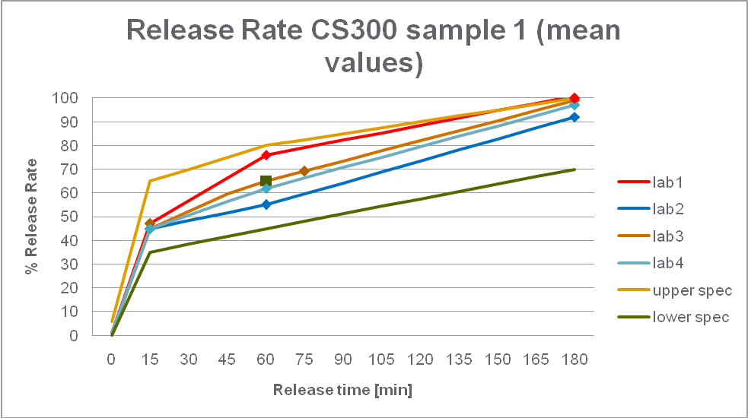

Fig. 2

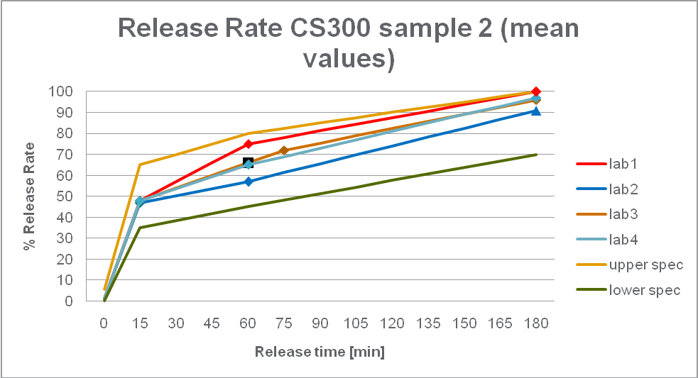

Fig. 3

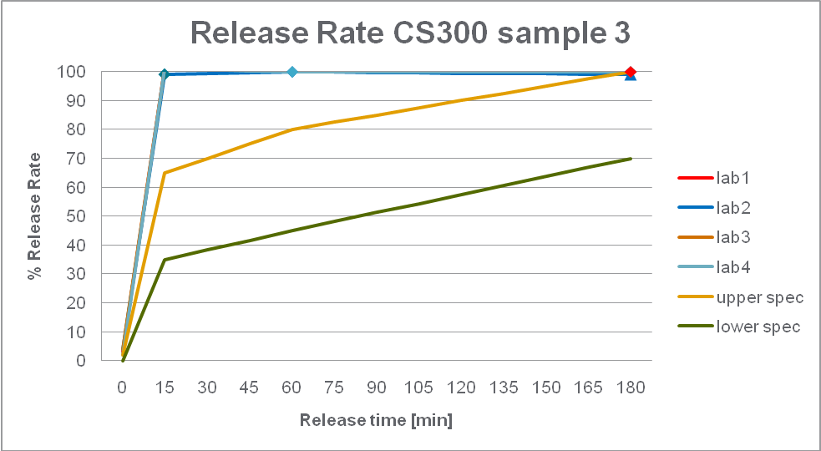

Fig. 4
Release after 15 min

Pirimiphos-methyl CS300 – sample 1

R limits

r limits

Mean

Fig. 5
Release after 15 min

Pirimiphos-methyl CS300 – sample 2

R limits

r limits

Mean

Fig. 6
Release after 15 min

Pirimiphos-methyl CS300 – sample 3

R limits

r limits

Mean
Fig. 7
Release after 60 min

Pirimiphos-methyl CS300 – sample 1

R limits

r limits

Mean

Fig. 8
Release after 60 min

Pirimiphos-methyl CS300 – sample 2

R limits

r limits

Mean
Fig. 9
Release after 60 min

Pirimiphos-methyl CS300 – sample 3

R limits

r limits

Mean

Fig. 10
Release after 180 min

Pirimiphos-methyl CS300 – sample 1

R limits

r limits

Mean

Fig. 11
Release after 180 min

Pirimiphos-methyl CS300 – sample 2

R limits

r limits

Mean

Fig. 12
Release after 180 min

Pirimiphos-methyl CS300 – sample 3

R limits

r limits

Mean

Conclusions

In this small scale collaborative study 4 different Labs have participated.

Each lab was sent two samples which were deemed biologically acceptable, samples 1 and 2, and one unacceptable sample, sample 3. The basis of acceptability was the biological activity, Laboratory Studies (Phase 1) as measured in the WHO guideline - WHO/CDS/NTD/WHOPES/GCDPP/2006.3 – for materials used as Mosquito Adulticides for Indoor Residual Spraying and Treatment of Mosquito Nets.

Upon review of the chromatographic data all results appear to be valid, even if the application of statistical outlier tests, Cochran and Grubb’s, report a straggler or outlier. These stragglers / outliers, although statistically significant, have not been identified as having any practical importance and hence have not been excluded. The variability afforded by this type of test had to be taken into account when assessing the results.

The variation in the roller speed appears to provide increased release rate values at the 60 min time point when using a slower speed, although this is not conclusive from such a small data set with other variables potentially giving rise to the variability of the results. Syngenta would recommend that the rotation speed is kept as close to the proposed value in order not to introduce further sources of variation.

The relative reproducibility standard deviation (RSD_{R}) is more than acceptable for the 15 min and the 180 min time points for all samples, <4%, when you consider that the Horwitz limit for a ‘Total AI’ CS300 analysis is 2.42%. The 60 minute time point sample 1 and 2 have higher RSD_{R} values, <15%, with sample 3 showing consistency with its’ other time points. The higher values are also deemed acceptable bearing in mind that this method is atypical and has many variables, such as solvent strength, stirring speed, solvent layer sampling and particle size distribution that can introduce additional variability compared with a typical method designed to monitor the total analyte content of a sample. The analytical variability is also increased due to the fact that normal laboratory techniques such as sonication and high shear mixing cannot be used to homogenize this formulation type as this may fracture the capsule walls which would compromise the data validity. All RSD_{R} values are deemed acceptable bearing in mind the complexity of this test in trying to differentiate between batches with acceptable and unacceptable biological profile.

All data for the samples representing acceptable biological performance, samples 1 and 2, conform to the proposed specification. The data at the 15 min and 60 min time points, for the sample representing unacceptable biological performance, sample 3, failed the specification which was expected.

Although it is extremely difficult to mimic the release of an active ingredient in the field, this work shows that a simple solvent extraction process can be used to illustrate the restriction provided by the capsule walls indicating which batches are acceptable and which are unacceptable biologically. The method can only be seen as indicative of biological profile, and not absolute confirmation, as the complexity of release in nature cannot be truly represented by this test.

We consider this method to be suitable as a specification test, without further changes, and recommend accepting it as a provisional CIPAC method for the Determination of Release Rate Characteristics of pirimiphos-methyl in CS 300 formulations.

